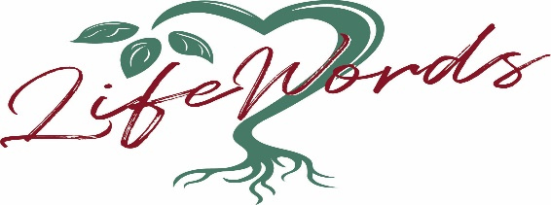
Rev. Susan Gumm – BIO
LifeWords of Montana

Susan retired as the Senior Minister at Unity on the Avenue Spiritual Center in Denver in June of 2020, after serving there for 8 years. She was ordained through the Field Licensing Program in March of 2017 and has been a Licensed Unity Teacher since 1997. Susan currently is serving on the Unity Northwest Regional Board of Directors as co-treasurer and Chair of our Retreat and Conference committee. She has been a part of the Unity movement for the past 39 years and also served as Treasurer and Conference Chair of the Unity South Central Region. Prior to serving as senior minister, she served as Associate Minister at Unity of Denver, Chair for SEE in the Field for two years for Unity Colorado and was the Adult Education Minister for 11 years. Susan is a certified Life Celebrant.
Susan relocated to Missoula to be with family and enjoy exploring the Montana mountains and rivers. Her ministry LifeWords of Montana gives expression to the most important occasions in life; the joy and sacredness of a wedding ceremony, the celebration of the life of a loved one, the blessed birth of a child, the retirement of a friend, and sharing her years of love of teaching the Unity principles through workshops and guest speaking engagements.
Susan has a Master’s of Divinity from Iliff School of Theology in Denver; undergraduate degree from Regis University in Religious Studies in Denver; and degree in marketing from Davenport University in Michigan.
Rev. Susan Gumm is dedicated to helping others uncover the best in themselves! Her wish is to foster the awakening of each individual’s unique gifts and talents so that they may be an expression of Divine in the world. Each day should be celebrated - “Be Inspired!”
